Process Flow Diagram Example
Food & Nutrition Division

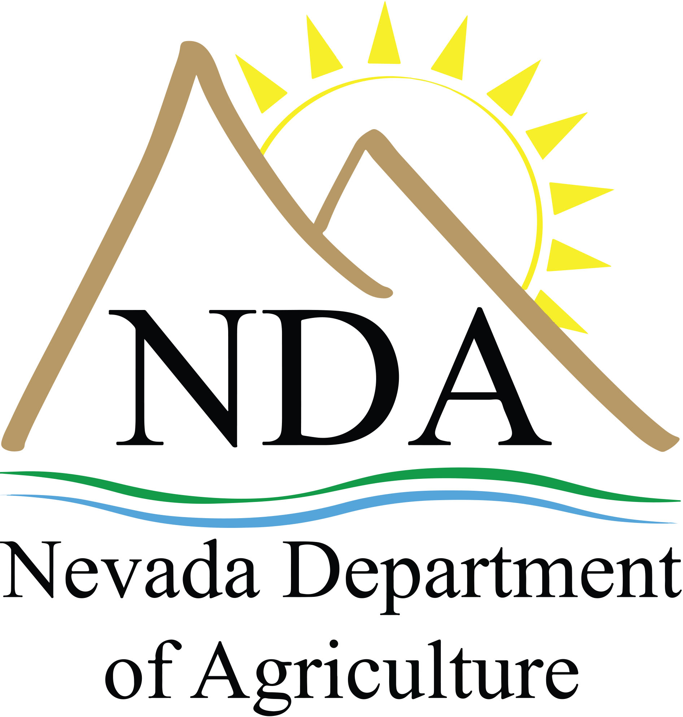

A process flow diagram is a required element of the plan review. In your diagram, include important information such as the location(s) of each process, critical control points, etc. If you have additional questions, please contact Jorge Bertran at jbertran@agri.nv.gov.

